**Olympic Pipeline Explosion**

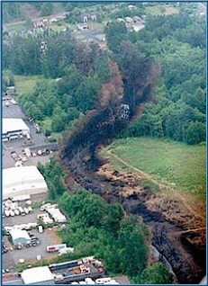

Olympic Pipeline Explosion

Photo by David Willoughby

Copyright Bellingham Herald

As an example of an unintentional threat, a 16-inch gasoline pipeline operated by Olympic Pipeline Company ruptured due to a pressure surge caused by a faulty pressure relief valve. The rupture released gasoline into Whatcom Creek in Bellingham, WA. This unfolding tragedy was exacerbated by the inability of the Supervisory Control and Data Acquisition (SCADA) to perform control and monitoring functions. The gasoline in the river was accidentally ignited, which resulted in an explosion and fire.

The explosion resulted in three fatalities, over $45M in property damage, and matching fines of $7.86M against two companies.

The database used by the pipeline SCADA system was modified in real time, without the necessary review to ensure the changes would not impact normal operations and safety of the pipeline.

The unchecked changes were implemented to the live database, causing a critical slowdown in system monitoring. These changes resulted in the SCADA system polling operational data from the pipeline every 6 minutes, rather than every 3 seconds.